UNIT TWO: INTRODUCTION TO ALGEBRA

Lesson One: Communicate with Algebra

Learning Goals – By the end of this lesson, you should be able to:
- Define and be familiar with the various terms used in algebra
- Identify the degree of a term and the degree of a polynomial
- Interpret a word problem and write a polynomial expression that describes it

Term | Definition | Example
Variable | A letter that represents a value.
Term | A number or variable or product of numbers and variables.
Algebraic Expression | An expression that includes numbers and variables. | _____________________ has ______ terms.
Like Terms | Terms which have exactly the same variables raised to exactly the same exponents. | _____________________ are like terms.  _____________________ are like terms.
Unlike Terms | Terms which have different variables or the same variables but different exponents. | _____________________ are unlike terms.  _____________________ are unlike terms.
Constant Term | A term that does not include a variable.
Coefficient | The number in front of a variable. | In the expression $3x-y-4$  Coefficient of $x$ is ______  Coefficient of $y$ is ______  Constant terms is ______
Polynomial | An algebraic expression with one or more terms.
Monomial | A polynomial with one term.
Binomial | A polynomial with two terms.
Trinomial | A polynomial with three terms.

Degree of a term: The sum of the exponents on the variables in a term.

Degree of a polynomial: The degree of the highest-degree term.

Example 1: Find the degree of each term.  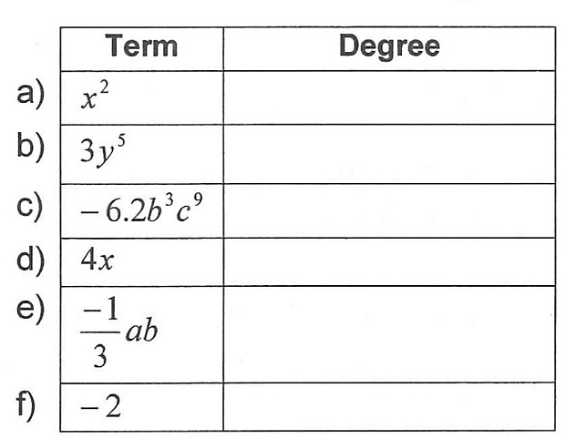 | Example 2: Find the degree of each polynomial.  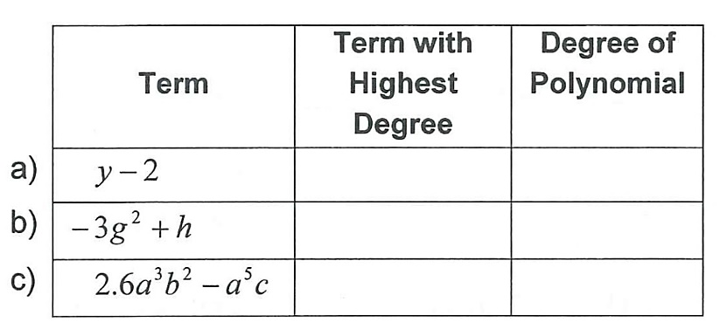

Example 3: Trevor has a part-time job working a used DVD and book store. He earns a base salary of $200 plus 15% on book sales and 8% on DVD sales.

a) Write a polynomial expression that describes his total pay.

b) How much will Trevor’s pay be if he made $425.80 in book sales and $687.75 in DVD sales?

Homework: p. 134 #C1, C2, #1-13, 15

Lesson Two: Collecting Like Terms

Learning Goals – By the end of this lesson, you should be able to:
- Identify like terms
- Re-arrange and simplify expressions by collecting like terms
- Adhere to mathematical form by writing the terms of the polynomial in descending order of exponents on variables and placing the variables in alphabetical order

RECALL: LIKE TERMS are terms that contain the same variables raised to the same exponents.
For example, $3x^{2}, -2x^{2}, x^{2}$
$x, 3x, -5x$
8, -10, 13

Example 1: Simplify by collecting like terms.
a) $4a+3+2a-4$ | Re-arrange the expression by grouping all the a’s together and the numbers together.

b) $3x+2x+2-3$ | c) $3+4x-7$
d) $4x^{2}-8x+2+4x-7x^{2}+3$ | e) $5a-2b+3a+4b-2a+3b$
f) $x^{2}y-xy^{2}+3x^{2}y-3xy^{2}$

Homework: p. 150 #C1, C2, #1, 2, 5-9, 12, 15

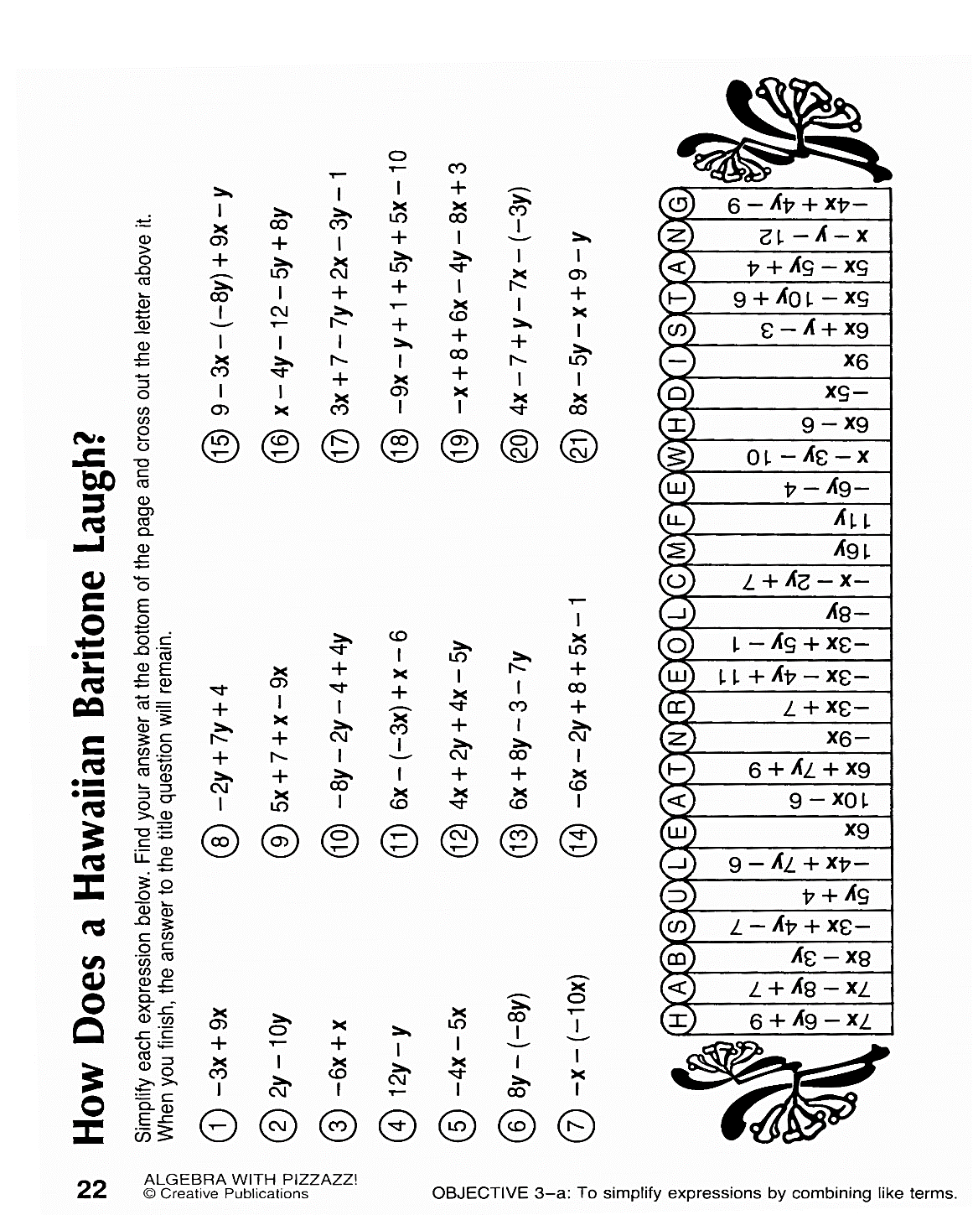
Lesson Three: Adding and Subtracting Polynomials

Learning Goals – By the end of this lesson, you should be able to:
- Add two or more polynomials together by grouping like terms and adding/subtracting their coefficients
- Using the DISTRIBUTIVE PROPERTY to expand
- Subtract a polynomial by treating the negative sign in front of the brackets as a “-1” coefficient
- Interpret a word problem, create an expression and simplify

To add polynomials, group like terms and simplify by adding or subtracting the coefficients of the like terms.

Example 1: Simplify the following expressions.
STEPS:
- Remove the brackets
- Group like terms
- Simplify

The Distributive Property

Before learning to subtract polynomials, we must learn how to use the DISTRIBUTIVE PROPERTY.

The DISTRIBUTIVE PROPERTY says that we can remove (or expand) the brackets when the term outside the brackets is multiplied with (or is distributed to) each term inside the brackets.

Example 2: Simplify.

STEPS:
- Multiply the 2 with the $x$
- Multiply the 2 with the +6
- Collect like terms
- Simplify
$$2\left(x+6\right)$$

Example 3: Expand and simplify. Pay attention to example c).

If you see just a negative sign in front of the brackets, think of it as a (-1) coefficient. This often causes mistakes for students. It maybe helpful to change the “−“ to (-1)” as seen below.

Example 4: Simplify.

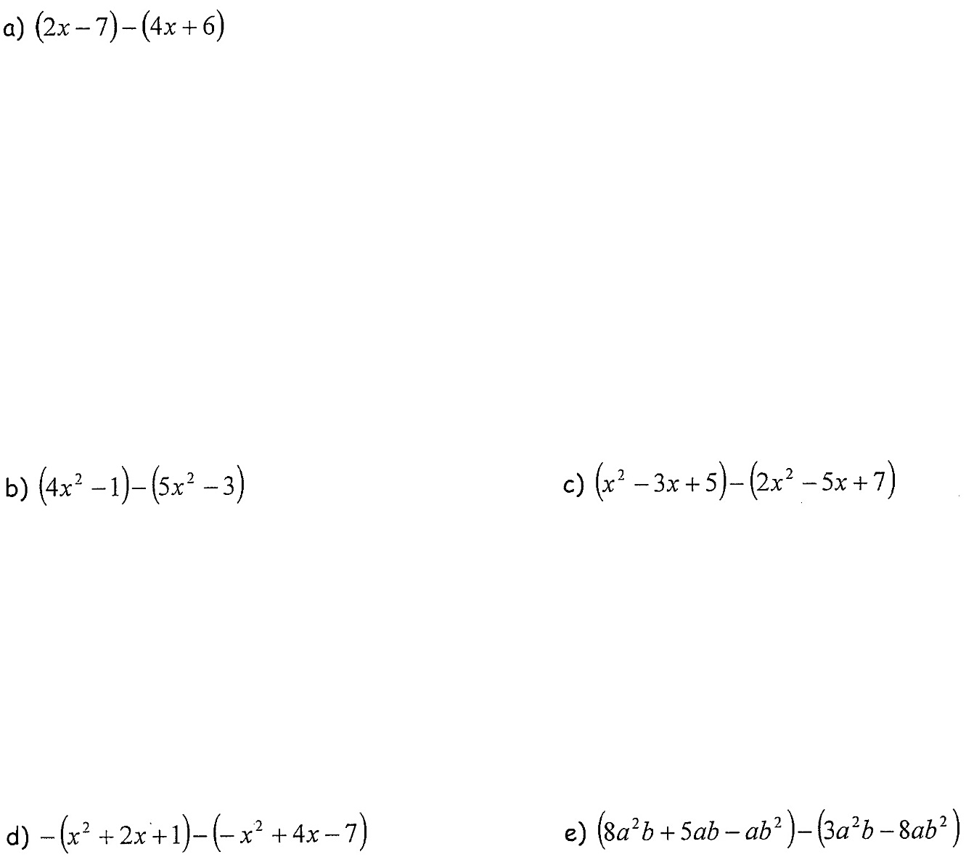
STEPS:
- Change the subtraction sign in front of the brackets to -1.
- Remove the brackets for the first polynomial and multiply every term in the second bracket by (-1)
- Collect like terms.
- Simplify.

Example 5: Players on a soccer team are paid according to the following breakdown, where n is the number of goals scored.

Player | Fixed Rate ($) | Additional Earnings  (for n goals scored)
Christine | 80 000
Desiree | 70 000 | 100 n
Nichelle | 50 000 | 600 n
Rebecca |  | 1000 n

a) Determine a simplified expression for the total earnings for these four players.

b) Determine the total earnings for these four players if they scored 18 goals each.

Homework: Handout(s) and p. 157 #2acef, 4acef, 6
Adding and Subtracting Polynomials Handout I

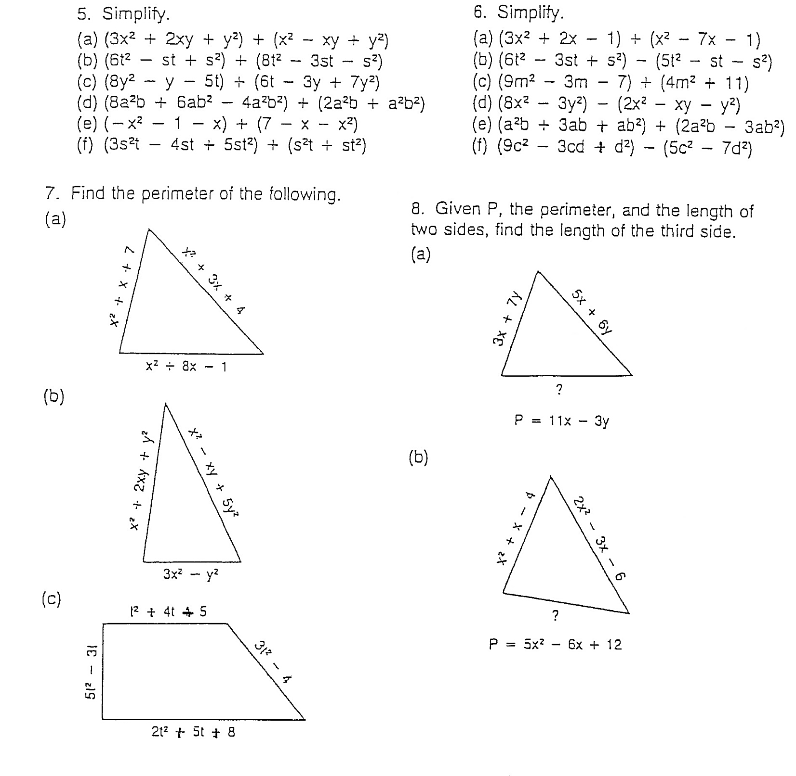

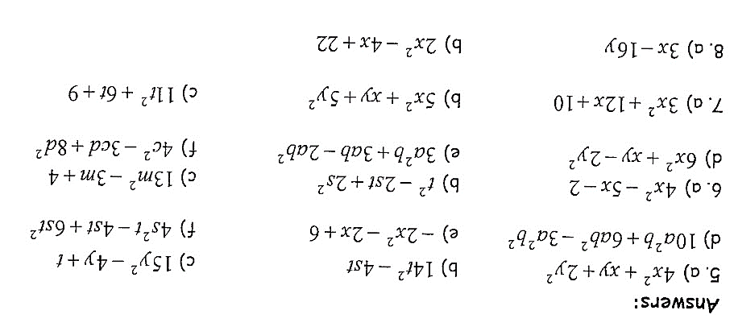

Adding and Subtracting Polynomials Handout II
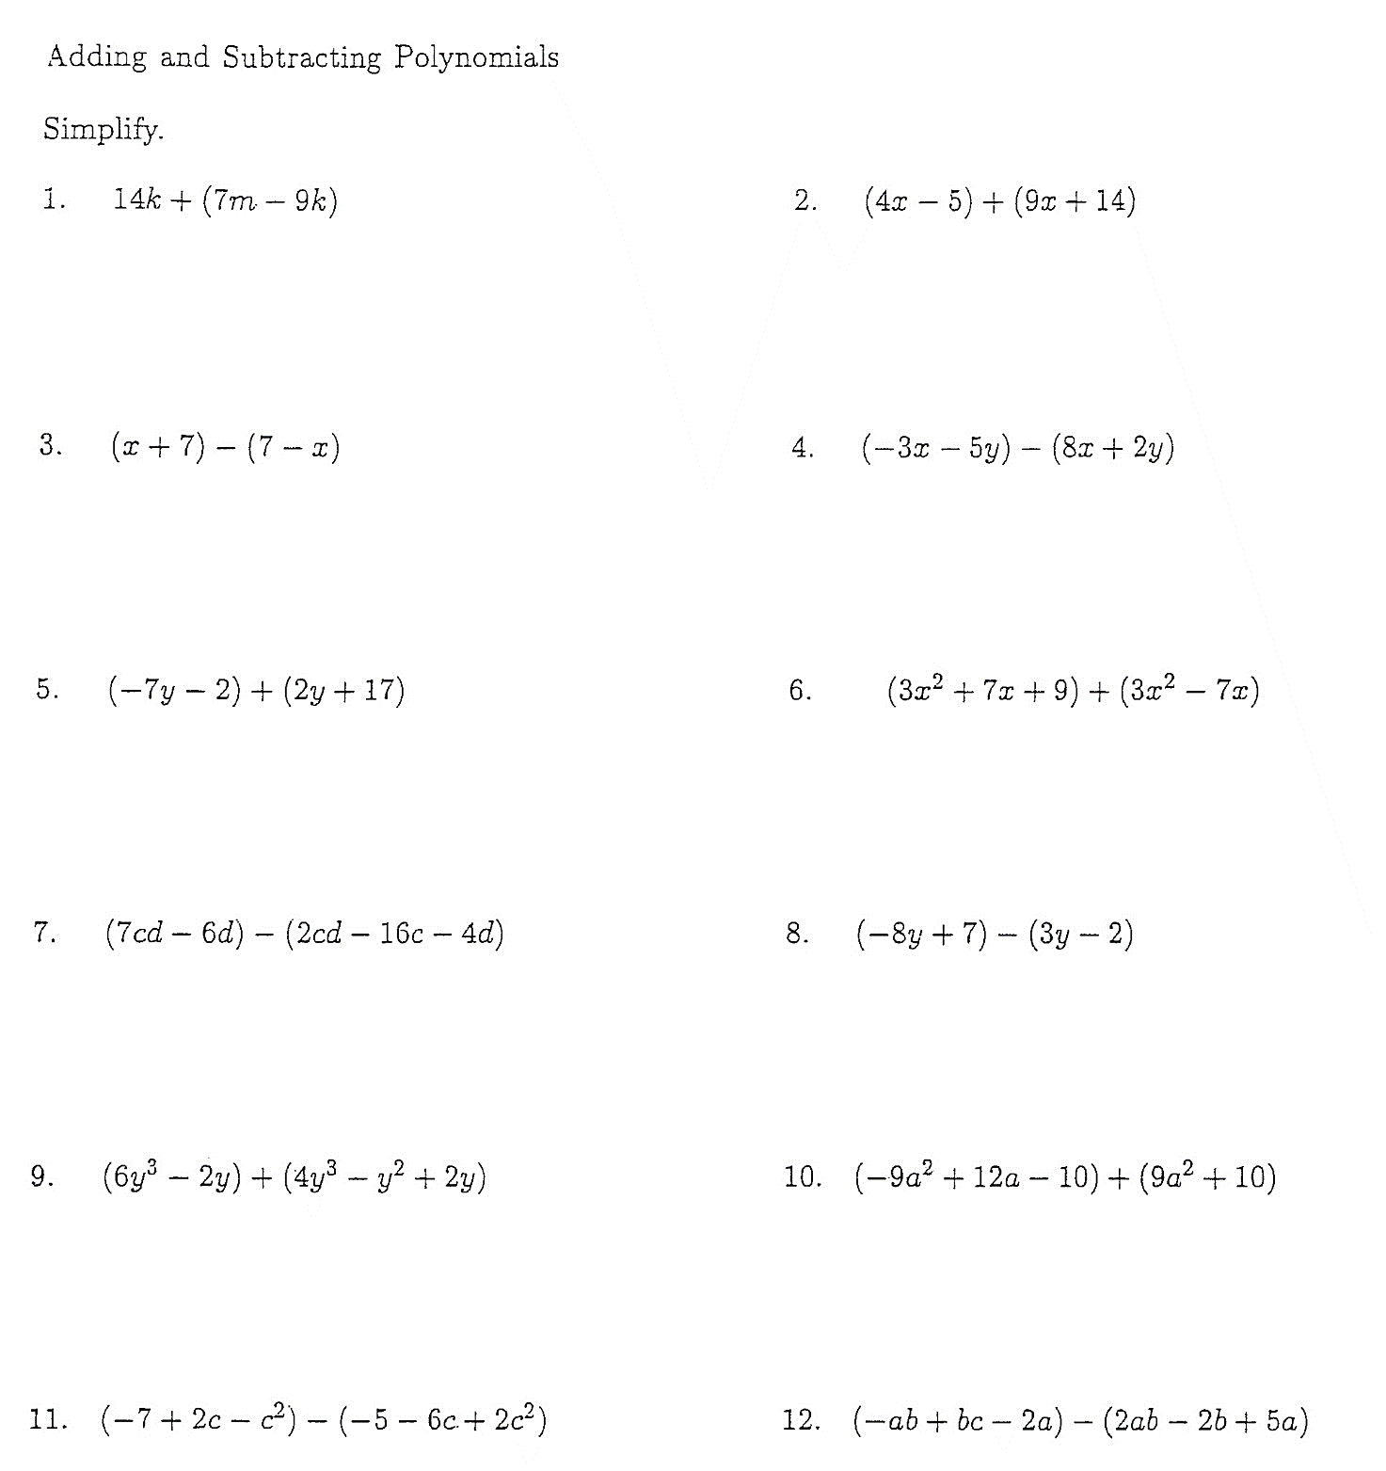

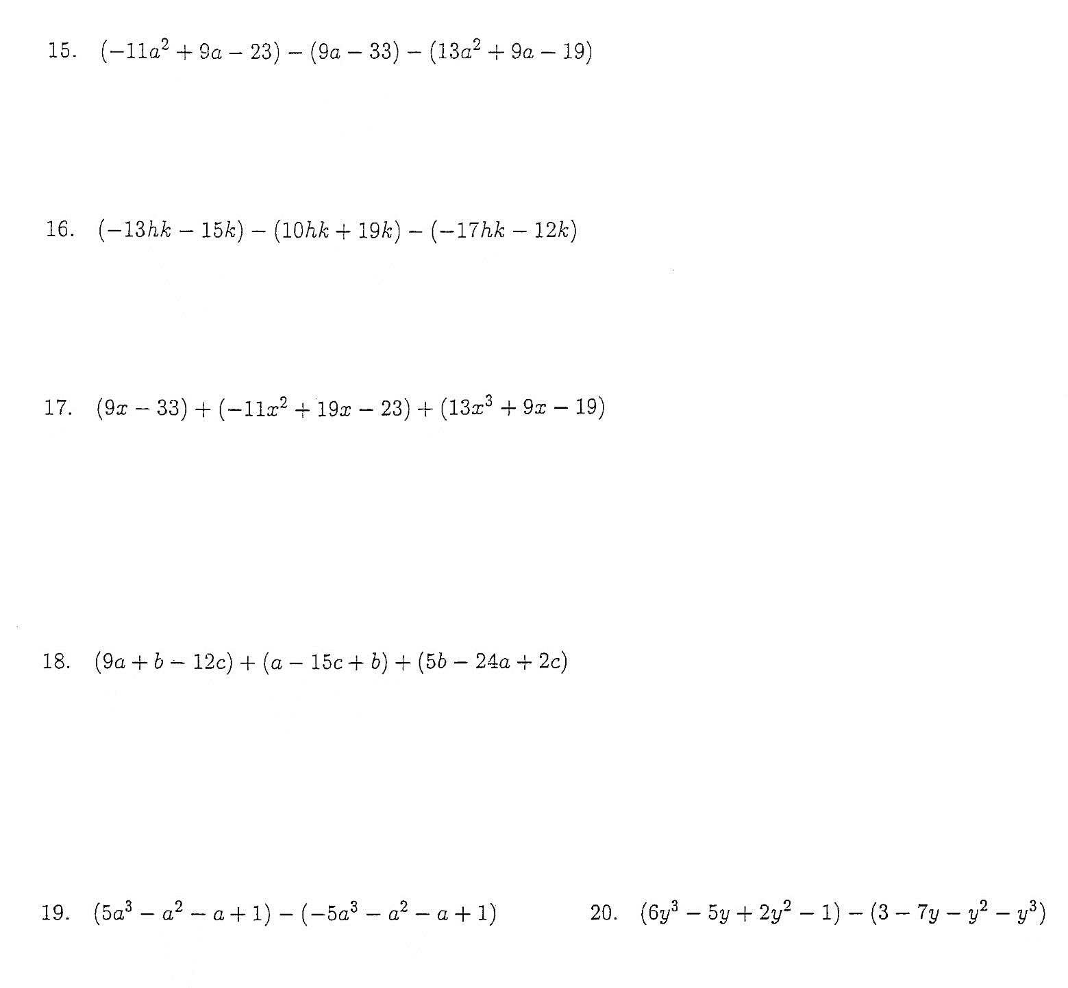

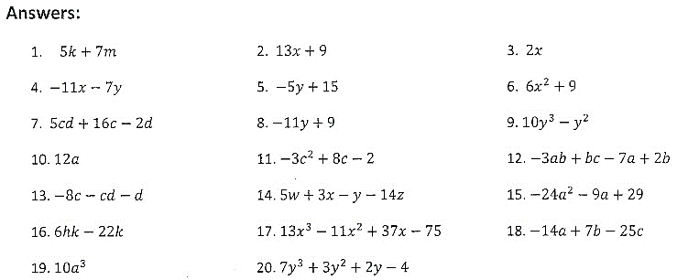

Lesson Four: Multiplying and Dividing Powers with the Same Base

Learning Goals – By the end of this lesson, you should be able to:
- Distinguish between the base and the exponent
- Explain how a power is essentially a short form of multiplication
- Expand a power into multiplication
- Multiply powers of the same base
- Divide powers of the same base

Powers are a useful way to express repeated multiplication.

For example, $3 x 3 x 3 x 3=3^{4}$.

$$3^{4}$$

Example 1: Identify the base and the exponent of each power.

Base:  Exponent: | Base:  Exponent: | Base:  Exponent: | Base:  Exponent:

Example 2: Write each expression as a power.

Example 3: Write in expanded form, then evaluate.

Explain why the answers to (b) and (c) are different.

MULTIPLYING POWERS

Product of Powers | Product Form | Power Form
$${10}^{2} × {10}^{3}$$

$$5^{3} × 5$$

What conclusion can you come to when you are multiplying powers of the same base?

Multiplying Powers of the Same Base

When multiplying powers of the same base, keep the base the same and _____________ the exponents.

In general:

Example 4: Simplify. (Express as a single power).

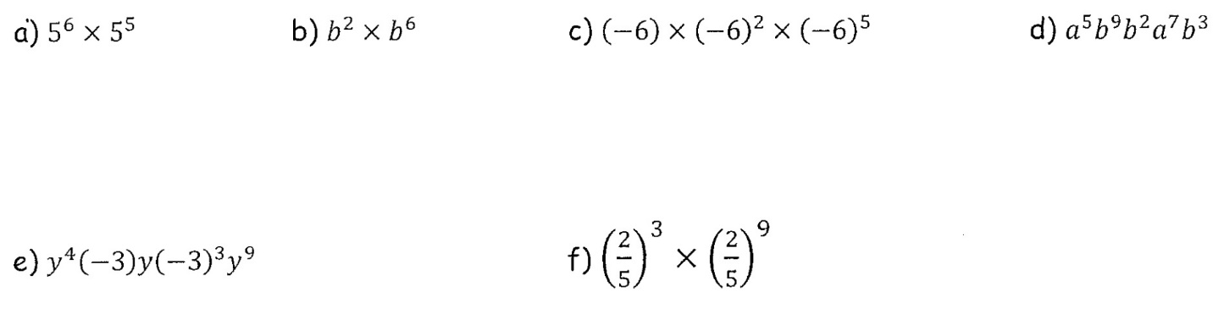

Can we add the exponents for 10⁵ × 6⁴? Explain why or why not.

DIVIDING POWERS

Quotient of Powers | Quotient Form | Power Form
$${10}^{5} ÷ {10}^{3}$$

$$9^{4} ÷ 9^{3}$$

Dividing Powers of the Same Base

When dividing powers of the same base, keep the base the same and _______________ the exponents.

In general:

Example 5: Simplify.

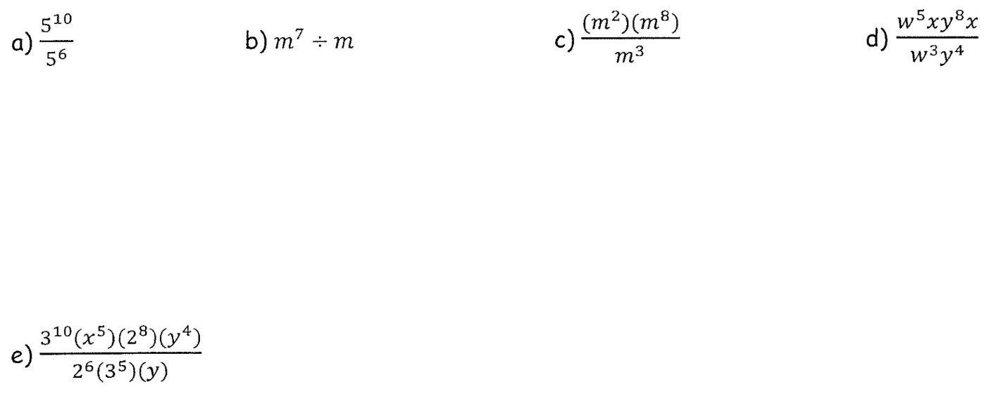

Example 6: Simplify and then evaluate.

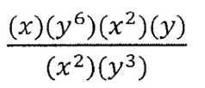
Example 7: Simplify and then evaluate for $x=3$ and $y=-1$.

Homework: p. 114 #1-3, 8 and Handout #1-8, 9ab, 11, 12abcde

Answers to Handout on Next Page
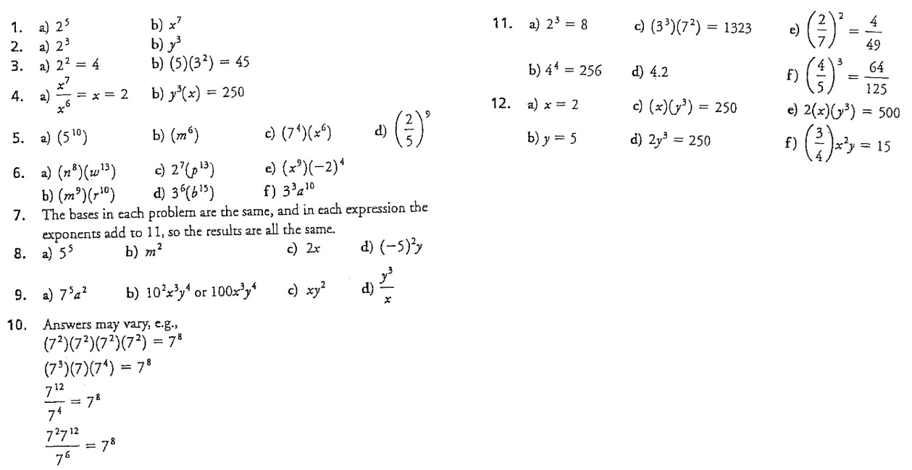
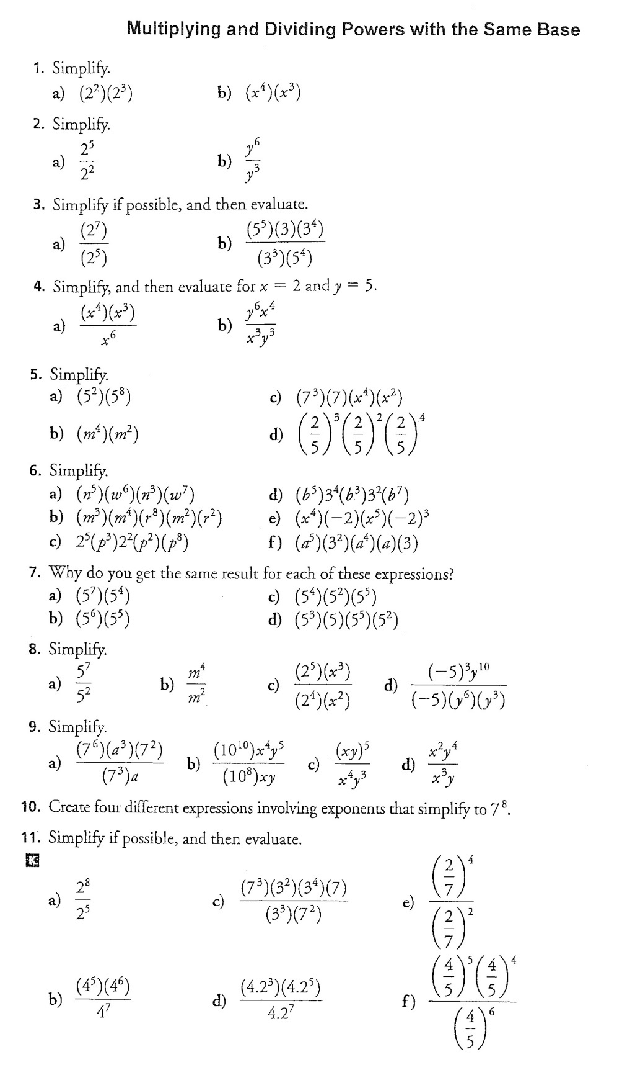
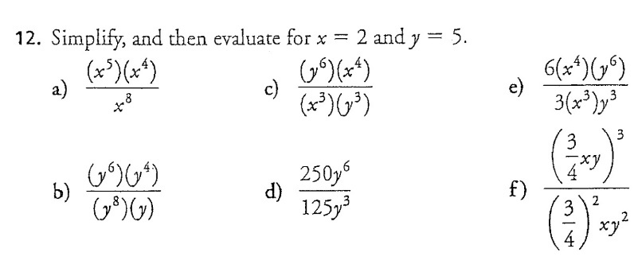

Lesson Five: Power of a Power

Learning Goals – By the end of this lesson, you should be able to:
- Simplify and evaluate expressions with powers of powers
- Simplify expressions by re-writing the base as a power

Example 1: Evaluate the following expression: ${{(2}^{3})}^{4}$. This can be done in two ways:

Method One | Method Two

Power of a Power Law

Keep the base the same and ______________ the exponents.

In general,

Example 2: Simplify the following.

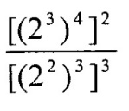
Example 3: Evaluate

Example 4: Simplify and evaluate for $x=1$ and $y=2$.

Example 5: Re-write each of the following powers in a simplified form.

a) 9³ as a power of 3 | b) 16⁵ with base 2

Homework: Handout # 3,4,6-9,11,12,15-17
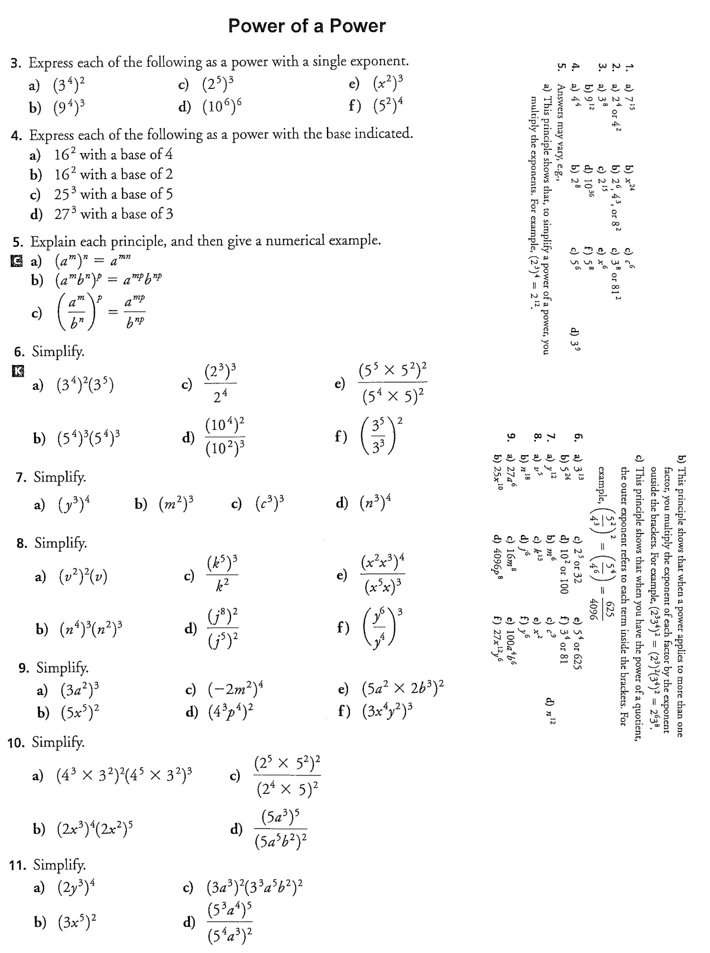

Answers

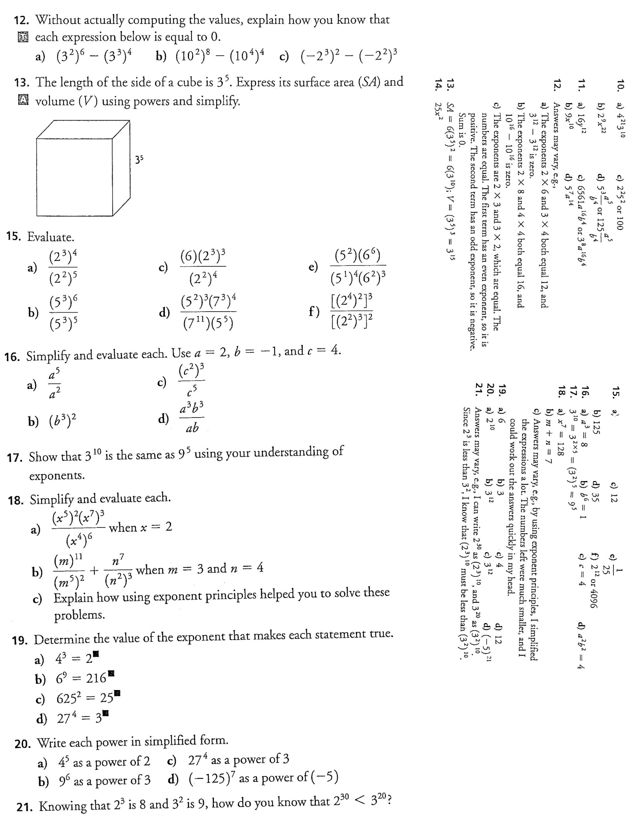
Lesson Five Extension: Zero Exponent Law

Evaluate the following by first simplifying: $\frac{2^{3}}{2^{3}}$.

Method One | Method Two

Zero Exponent Rule

Any base raised to the exponent zero is equal to _______________.

In general,

Example 1: Evaluate the following.

a) 1023⁰ | b) 5⁰ | c) -4⁰ | d) (-8)⁰ | e) b⁰ | f) $\frac{a^{5}b^{4}c^{8}}{a^{3}b^{4}c^{5}}$

Lesson Six: Multiplying a Monomial by a Monomial

Learning Goals – By the end of this lesson, you should be able to:
- Multiply or divide a monomial by a monomial and simplify the expression

Recall: A polynomial with only one term is called a MONOMIAL. A COEFFICIENT is the number in front of the variable.

To multiply two monomials, multiply their coefficients and multiply their variables.

Example 1: Simplify.

a) 5y (3y²) | b) 2x (4y) | c) 4a²b⁵c(2b³c⁴)(3a⁴b)

d) -2x²y⁴ (5x) (-yw²) | e) 35d³f²($\frac{-1}{5}$f)
f) (a^{2n + 3})(a^{n - 7}) | g) (b^{5x - 2})(b^{3x + 6})

Example 2: Calculate the area of the rectangle.
3b²
2ab

Dividing Monomials by Monomials

To divide two monomials, divide their coefficients and divide their variables.

Example 1: Simplify.

a) $\frac{-8x^{6}y^{7}}{4x^{5}y^{5}}$ | b) $\frac{60a^{4}b^{3}c^{8}}{30a^{2}bc^{2}}$
c) $\frac{36x^{5}y^{3}}{6xy^{3}}$ | d) $\frac{20d^{6}e^{3}f^{8}}{16d^{2}e^{2}f^{5}}$

Example 2: Find the missing dimension in the rectangle.
A = 3a³b⁴
a²

Homework:
Multiplying: Handout #3odd, 4odd, 5odd, 6odd, 7odd, 8odd
Dividing: Handout # 1odd, 2odd, 3odd, 4odd, 5, 6, 7

Multiplying Monomials by Monomials

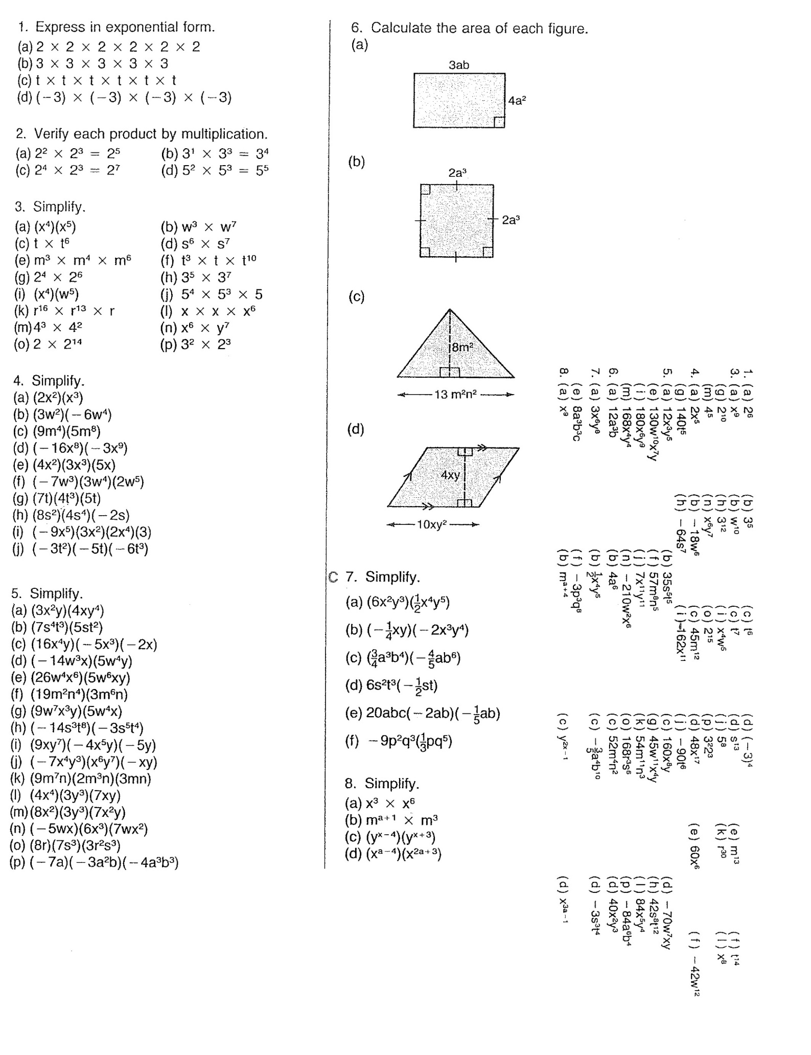
Answers

Dividing Monomials by Monomials
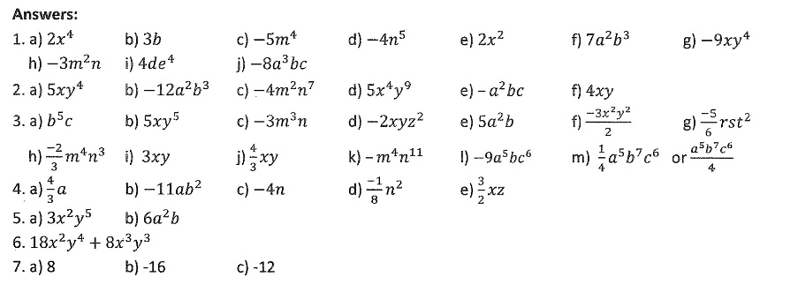
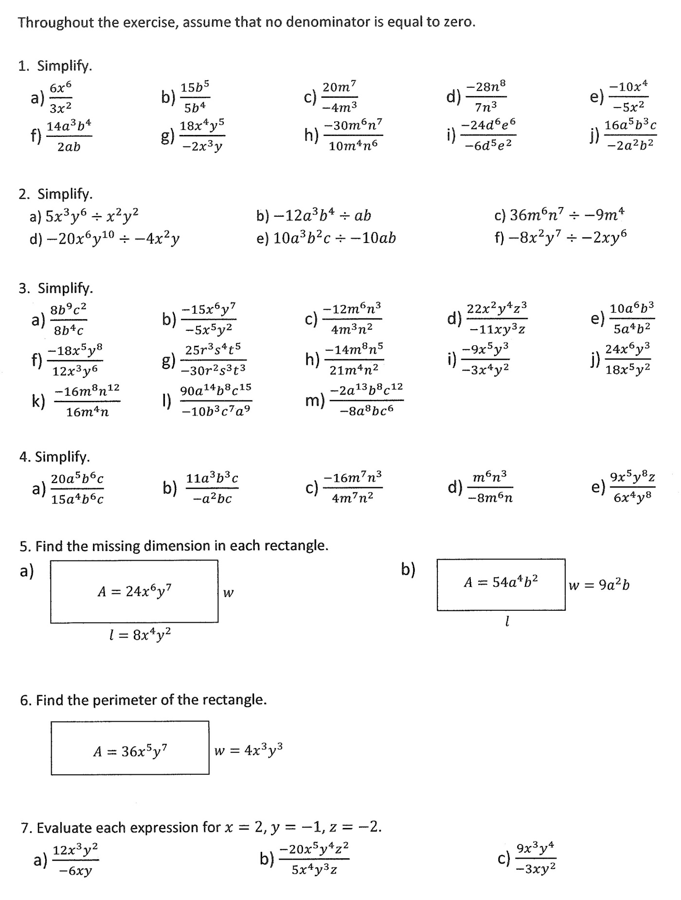

Lesson Seven: Multiplying a Polynomial by a Monomial

Learning Goals – By the end of this lesson, you should be able to:
- Multiply a polynomial by a monomial and simplify
- Multiply a polynomial by a monomial with fractions and/or decimals and simplify

To expand an algebraic expression means to remove the brackets and simplify. To do this, we use the DISTRIBUTIVE PROPERTY.

$$a\left(b+c\right)=ab+ac$$

When using the distributive law, we say we are EXPANDING the product.

Example 1: Expand the following.

a) 3(x + 5) | b) – (2 – x) | c) 4 (3x – 2y + 7)

Example 2: Expand and simplify.

a) – 2 (x + 3) – (x – 5) | b) 2x (x² – 2x + 5)
c) ab (3 – 5a) | d) 4x (x – 3) – 2 (x + 3)
e) 2 (3x² – 4x + 5) – 2x (x – 3) | f) 3x (x + 2) – (5 – 2x) 4

Homework: Handout #1- 4
Multiplying a Polynomial by a Monomial, Cont’d.

In the following examples, expressions will include decimals and fractions.

a) 0.3 (x – y) – 0.2 (0.6x + 0.4y) | b) $\frac{2}{3}\left(9x-15y\right)- \frac{6}{5} (5x+10y^{2})$
c) $\frac{x}{4}\left(4x+12\right)- \frac{4x}{3}\left(6x^{2}+9\right)$ | d) – 2x [x – 3(5 – 6x)] + 4x (3x – 5)

Homework: Handout #5 - 9
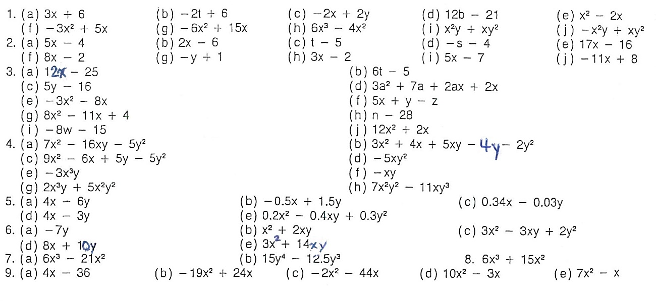

Answers to Handout
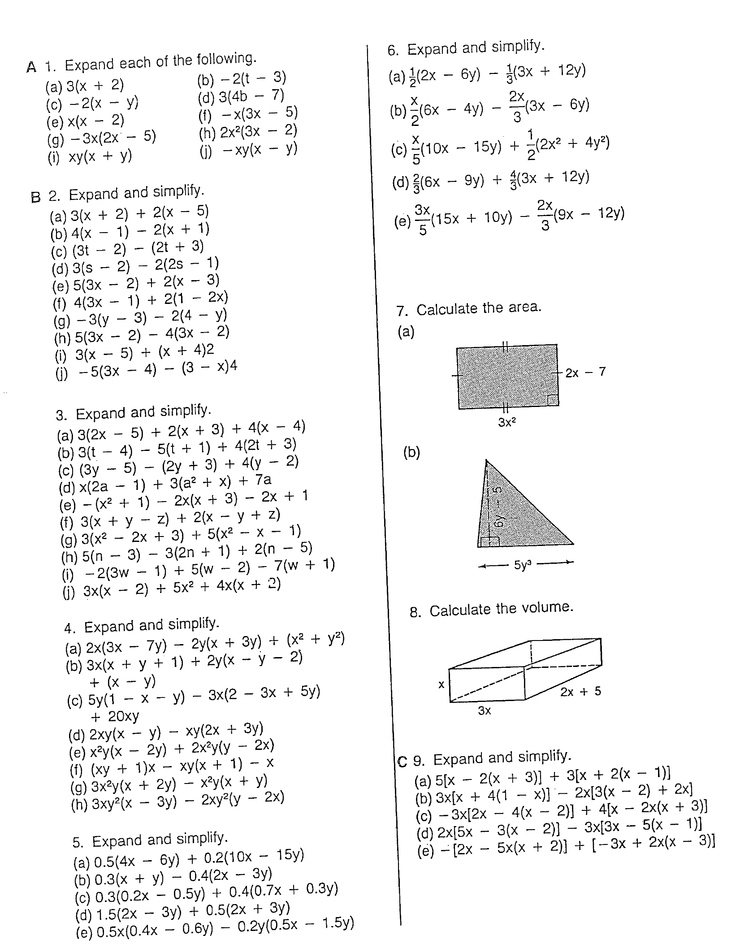
Multiplying a Polynomial by a Monomial

Review for Algebra Test
