Introduction to Chapter One: Getting Started
MathPower 10, Ontario Ed., McGraw-Hill Ryerson p. 3

By the end of this lesson, you should be able to:
- Simplify an expression with one or several variables
- Solve for a variable in an equation
- Rearrange an equation
- Graph lines using intercepts, slope and find the points of intersection

Simplifying Expressions
- Expand the expression by multiplying, dividing, etc.
- Collect like terms and then simplify

Ex. 1: 4(x + 2) – 2x | Ex. 2.: p – 2q – 3r + 2(p + q + 2r)

Solving for a variable in an equation

The goal here is to ISOLATE THE VARIABLE YOU ARE SOLVING FOR – get it to one side of the equation.

Ex. 3: 4x – 2 = 2x + 1

Ex. 4: $\frac{2y+1}{3}=\frac{y-1}{2}$

Solving an equation for another variable
The objective with these problems is to get isolate one variable in terms of another. Your answer will be an equation.

Ex. 5: 5y – x = 8; solve for x | Ex. 6: 3x – 2y = 4; solve for y

Graphing an equation using intercepts  - Set y = 0 to find the x-intercept  - Set x = 0 to find the y-intercept  - Connect to the two points  Ex. 7: x – 2y = 4 | Graphing an equation using slope and the y-intercept  - First set x = 0 to find the y-intercept  - Use rise/run to find the next point  - Connect the two points  Ex. 8: y = -1/2 x + 2

Graphing a Pair of Line and finding the Point of Intersection
- Graph the two lines (either using slope/intercept or by using the x, y-intercept method)
- Find the point where the two lines intersect
- This is called the SOLUTION to this system (The SYSTEM is the two linear equations)

Ex. 9: Graph and find the point of intersection for y = 3 – x and y = x – 7

CHECK YOUR LEARNING – can you do the following?
- Simplify an expression with one or several variables
- Solve for a variable in an equation
- Rearrange an equation
- Graph lines using intercepts, slope and find the points of intersection

Section 1.1 and 1.2: Solving Linear Systems Graphically
MathPower 10, Ontario Ed., McGraw-Hill Ryerson p. 4-15

By the end of this lesson, you should be able to:
- Define what a system is and know how many solutions
- Understand what an ordered pair is
- Graph two linear equations and determine the solution by intersection
- Know the three cases of solutions (i.e., one, none or infinite), how they look graphically and how their equations look
- Use a graphing calculator to graph a system of equations and find the point of intersection
- Analyse a system of equations without graphing it

IMPORTANT DEFINITIONS!
A system of equations is defined as a set of one of more equations with the same variables.
i.e.: x + y = 1  2x – ½ y = 0 | 3m + 2n + p = 1  m + n + p = -3  p = 2 | -5a = 3b + 2  $$b= \frac{a+3}{5}$$

A solution to the system of equations is when you are able to obtain a value for each of the variables that satisfies all the equations in the system.

A single equation with one variable has only ONE SOLUTION. For example, 2x + 1 = 7 can only have ONE real value for x that satisfies the equation – that is, x = _____.

A single equation with two variables can have INFINITE SOLUTIONS. For example, 2x + y = 9 is the equation of a line and, therefore, there are INFINITE points on this line that satisfy the equation. Some are (0, 9), (1,7), (3,3) and (-1, 11).

How many solutions would 0x = 0 have? ___________________________________________________________________________

Discovering the Three Cases of Solutions in a Linear System

Graph the following equations and determine the solution to the system of equation.
y = x + 4
y = 2 – x

Fill in the following chart:
Graph of System | Compare the slopes | Compare the y-intercepts | How many solutions?
Graph the following equations and determine the solution to the system of equation.
y = 2x + 3
y = 2x - 4

Fill in the following chart:
Graph of System | Compare the slopes | Compare the y-intercepts | How many solutions?

Graph the following equations and determine the solution to the system of equation. First, change the two equations into slope/intercept from (y = mx + b).
x + y = 3
2x + 2y = 6

Fill in the following chart:
Graph of System | Compare the slopes | Compare the y-intercepts | How many solutions?

Graphs of Lines | Slopes of the two lines | Intercepts of the two lines | Number of Solutions

Analyzing Systems of Equations without graphing them
Now that you know how the slopes/intercepts give clues about the solutions to systems, you don’t need to graph the system to determine whether it has one solution, no solutions or infinite solutions.

Basically, convert the two equations to slope/intercept form (y=mx + b) and then analyse their slope and intercepts.

2x + y = 6  y – 8 = -2x | 3x + y =1  6x + 2y = 2 | 2x + y – 4 = 0  x + 2y – 6 = 0

Check your learning – are you able to:
- Define what a system is and know how many solutions
- Understand what an ordered pair is
- Graph two linear equations and determine the solution by intersection
- Know the three cases of solutions (i.e., one, none or infinite), how they look graphically and how their equations look
- Use a graphing calculator to graph a system of equations and find the point of intersection
- Analyse a system of equations without graphing it

Section 1.3: Solving Linear Systems by Substitution
MathPower 10, Ontario Ed., McGraw-Hill Ryerson p. 16-23

By the end of this lesson, you should be able to:
- Solve a system of two linear equations by substituting one into the other
- Conclude whether the system has one solution, infinite solutions, or no solutions
- Based on the solution, describe how the system would look graphically

Recall: a SYSTEM OF EQUATIONS is a way of saying there are a number of equations with the same variables. The following are systems of equations.
i.e.: x + y = 1  2x – ½ y = 0 | 3m + 2n + p = 1  m + n + p = -3  p = 2 | -5a = 3b + 2  $$b= \frac{a+3}{5}$$

In this lesson, you will be solving a system of two linear equations using algebra. Remember, a system of equations can have one solution, infinite solutions or no solution.

One solution  - Means you can obtain an answer for both variable  - Graphically, the two lines would intersect at a point (solution) | Infinite solutions  - Means there are an infinite number of solutions for both variables  - Graphically, the two lines are “on top of each other” or “coincident” | No solution  - Means there is no answer for either variable that will satisfy the equation  - Graphically, the two lines are parallel and distinct

You can solve a system by substitution as follows:
- Number your equations (1) and (2)  - Re-arrange one of the equations to isolate a variable  - Write out the other equation  - Substitute the rearranged equation into the equation you just wrote out | - Expand, collect like terms and simplify  - Solve for one variable  - Using the value of that variable, solve for the missing variable  - Check your answer by substituting the two values into each equation
Ex. 1: Solve the following system of equations by substitution; describe the solution graphically.
x + 3y = 2
2x + 5y = 3

Ex. 2: Solve the following system of equations by substitution; describe the solution graphically.
-4a + 2b + 6 = 0
8a – 4b – 12 = 0

Ex. 3: Solve the following system of equations by substitution; describe the solution graphically.
2s + 2t = 7
3(s+1) – 3(-1-t) = 18

CHECK YOUR LEARNING – are you able to?
- Solve a system of two linear equations by substituting one into the other
- Conclude whether the system has one solution, infinite solutions, or no solutions
- Based on the solution, describe how the system would look graphically
(Challenge: #12, 13 and 14)
Section 1.5: Solving Linear Systems by Elimination
MathPower 10, Ontario Ed., McGraw-Hill Ryerson p. 26-33

By the end of this lesson, you should be able to:
- Solve a system of two linear equations through elimination of one of the variables
- Manipulate the two equations by multiplication and subtraction to eliminate a variable
- Re-write equations that have decimals
- Re-write equations with fractions

So far, you have been able to solve a system of two linear equations by graphing and by substitution. In this lesson, you will learn how to solve a system by ELIMINATION.

The steps are as follows:
- Label your equations as (1) and (2)  - Line the up on top of each other so that the two variables align  - Decide which variable you are going to eliminate  - Multiply equations (1) and (2) by numbers that will give you AN OPPOSITE coefficient for the variable you are going to eliminate | - Add the two equations and solve for the left over variable  - Go back to either equation (1) or (2) and substitute the value of the variable you just solved for  - You now have the values of your two unknown variables

Ex. 1: Solve the system by elimination. Check your answer.
5x + 2y = -11
2y + 3x =-9

Ex. 2: Solve the system by elimination. Check your answer.
8c – 3d = -10
2c – 5d = 6

Solving linear systems with decimals
Sometimes an equation will have a decimal coefficient. Since it is easier to work with integer coefficients, we can multiply the equation by 10, 100, 1000, etc. to get rid of the decimals.

Ex. 3: Solve the system by elimination. Check your answer.
1.7x + 3.5y = 0.01
0.6x + 1.2y = 0

Solving linear systems with fractions
Again, some linear systems involve fractional coefficients. To get rid of the denominators, multiply the equation by the LCD (lowest common denominator). This will cancel the denominator and you can work with easier integers.
Example 4:
$$\frac{x}{2} + \frac{y}{8} =4$$
$$\frac{x}{3} - \frac{y}{2}= -2$$

Section 1.6: Translating Words into Equations
MathPower 10, McGraw-Hill Ryerson pp. 36-37

In this section, we are looking to translate words and problems into mathematical equations. We will develop this skill by working through examples together.
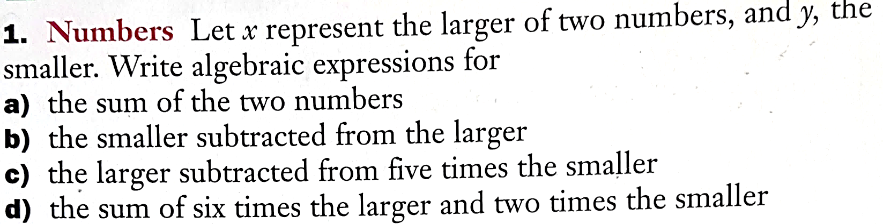

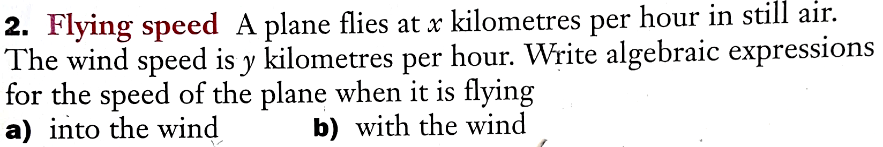

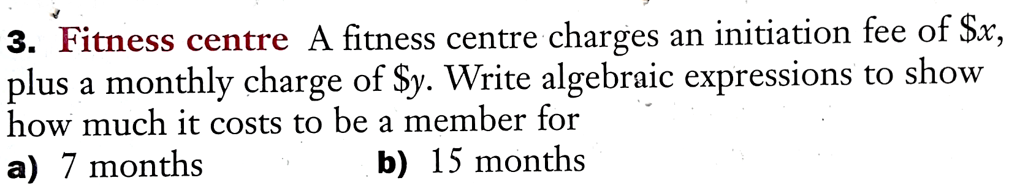

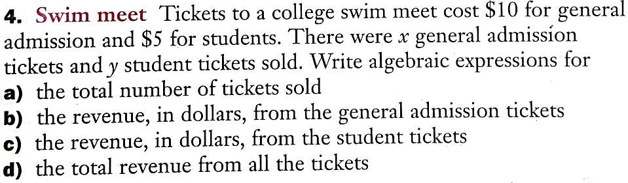

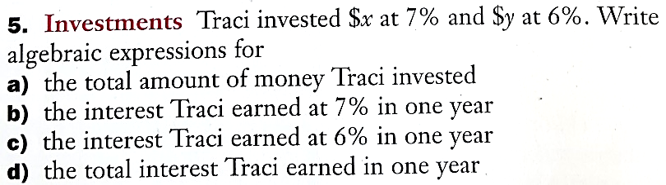

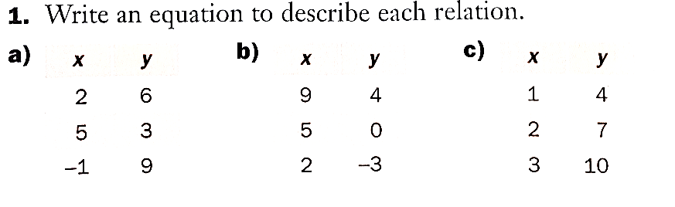

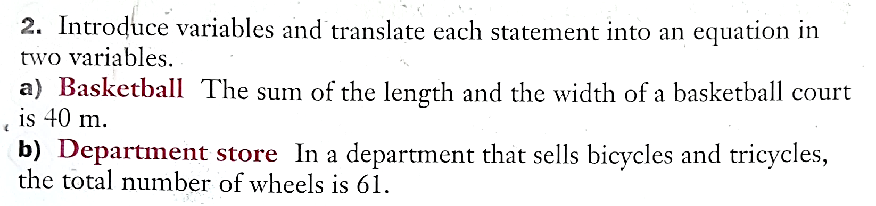

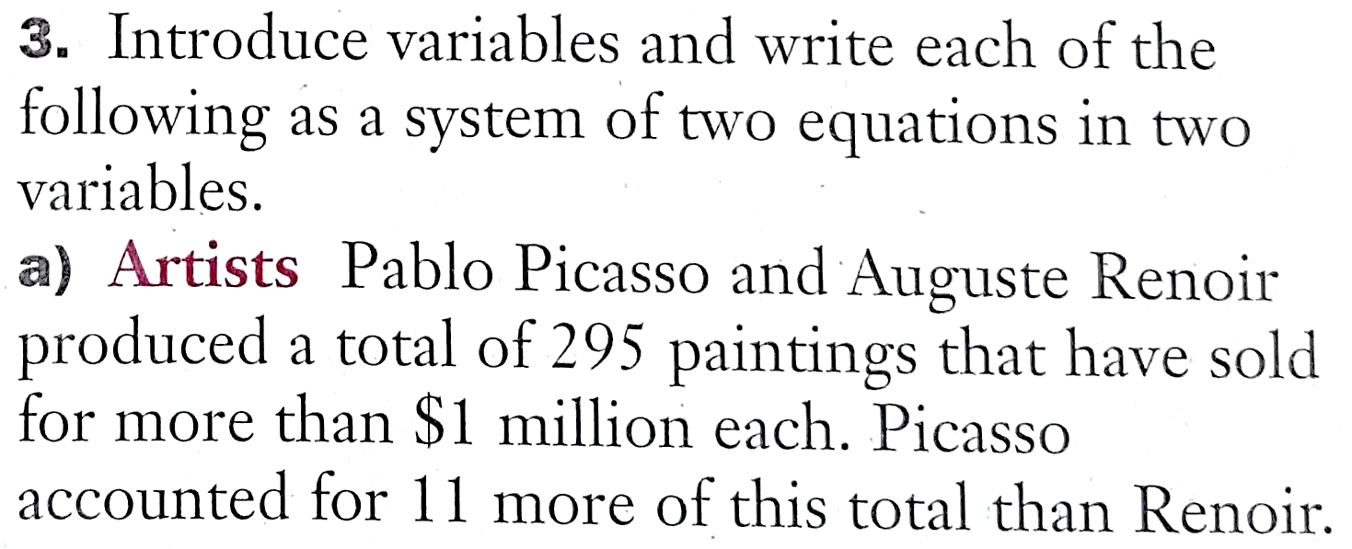

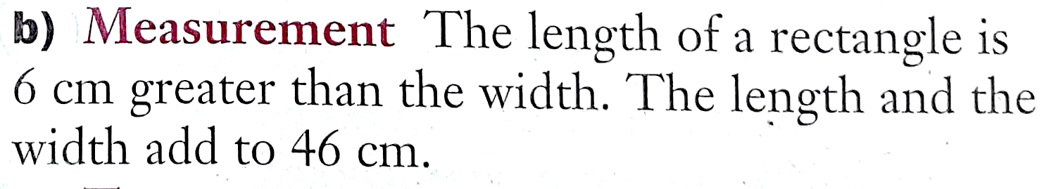

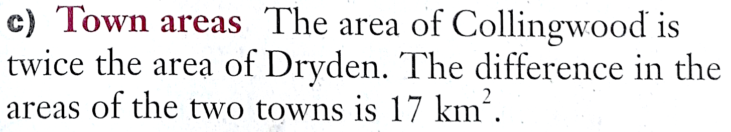

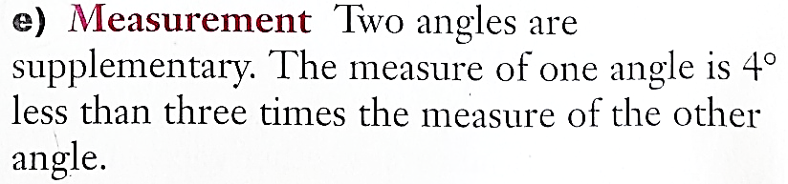

Section 1.7: Solving Problems Using Linear Systems
MathPower 10, McGraw-Hill Ryerson pp. 38-47

Now that you’ve learned how to translate words into equations, you will be setting up linear systems based on word problems.

The following are steps that may help you to solve these word equations:

- Read the problem carefully, identify the unknowns, and assign variables to the unknowns
- Determine how the unknowns are related
- Write a system of equations that shows relationships between the unknowns
- Solve the system of equations
- Check the solution, using the facts given in the problem

