UNIT TWO: Introduction to Chapter Three - Review of Power Rules

By the end of this lesson, you should be able to:
- Understand what an exponent is and be able to define a base
- Understand the various exponent rules and apply them

Basically, exponents allow us to write several multiplications in short form.

2 x 2 x 2  = 2³ | 3 x 3 x 3 x 3 x 3  = | 5 x 5  = | 3 x 3 x 3 x 2 x 2 x 2 x 2  =

Note: the number that is the same and being multiplied is called the BASE. The base doesn’t necessarily have to be a number – it could be a variable like x, y or a, b, etc.

s ⋅ s ⋅ s ⋅ s  = | a x b x b x b x a  = | x ⋅ y ⋅ x  = | m ⋅ m ⋅ m ⋅ m ⋅ m ⋅ n ⋅ n  =

PRODUCT RULES
When several variables of the SAME BASE are multiplied together, add their exponents.
Simplify the following expressions.
s ⋅ s ⋅ s ⋅ s  = | a² x b² x b³ x b x a  = | x ⋅ y ⋅ x⁴  = | m ⋅ m ⋅ m² ⋅ n ⋅ n³  =

Exponents can also be factored out or distributed.

Simplify s² ⋅ t²  = | Simplify x³ ⋅ y³ ⋅ z²  = | Expand (abcd)²  = | Expand (mn)⁴  =

QUOTIENT RULES
When you divide variables of the SAME BASE, you can subtract their exponents.
Simplify the following expressions.
$$\frac{s^{4}}{s^{3}}$$ | $$\frac{a^{2}b^{3}}{b^{2}}$$ | $$\frac{x^{2}}{x^{4}}$$ | $$\frac{{(mnp)}^{3}}{mp}$$

You can also factor out exponents. Simplify the following.
$$\frac{s^{4}}{t^{4}}$$ | $$\frac{a^{2}b^{2}}{c^{4}}$$ | $$\frac{x^{2}}{y^{6}}$$ | $$\frac{{(mnp)}^{3}}{{(jkl)}^{9}}$$

POWER RULES
An exponent OUSTIDE the brackets multiplies everything inside the brackets.

Expand the following.
(x²y)³ | $(\frac{a^{2}b^{2}}{c^{4}}$)² | (2s⁴tq²)²

FRACTIONAL EXPONENTS
A square root ($\sqrt{x}$) is actually the same as having the fractional exponent $x^{\frac{1}{2}}$. A cube root ($\sqrt[3]{x}$) is the same as $x^{\frac{1}{3}}$ .

Represent the following radicals as fractional exponents:
$$\sqrt{a}$$ | $$\sqrt[4]{b}$$ | $$\sqrt[3]{x^{2}}$$ | $$\sqrt[2]{y^{4}}$$

SIMPLIFYING THE BASE
Sometimes the base is actually a number raised to an exponent. For example, 8 is really 2³ and 525 is really 5⁴. Complete the following table:

1 | 4 | 9 | 49 | 25 | 36 | 81 | 121 | 16 | 100 | 64 | 144 | 225 | 169 | 196
1² |  |  | 7²

When simplifying the base, try to reduce it as far as possible to prime numbers. For example, simplify the following expressions:

 | $$\sqrt[3]{8x^{6}}$$ | $${(32a^{15}b^{25})}^{\frac{1}{5}}$$ | $$\sqrt[2]{(\frac{4}{b^{8}})}$$

ZERO EXPONENTS
Any number or variable raised to the exponent zero is equal to one.

43⁰ | b⁰ | $${(32a^{15}b^{25})}^{0}$$ | $$\frac{{(mnp)}^{0}}{mp}$$

NEGATIVE EXPONENTS
Any number or variable raised to a negative exponent means you must then take the reciprocal of that number or variable.

NOTE: the number or variable raised to the negative exponent cannot equal zero.

Re-arrange the following expressions so that they have positive exponents.

$$x^{-2}$$ | 2⁻²
3⁻² | (s⁻¹)²
$$\frac{1}{2^{-1}}$$ | m⁻⁴ x m⁻⁵
t⁻¹ | y⁻⁵ ÷ y⁻³

Powers Homework Handout #1
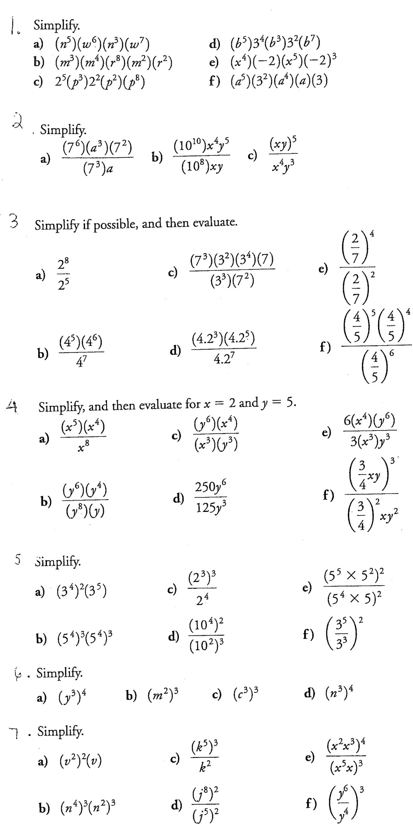
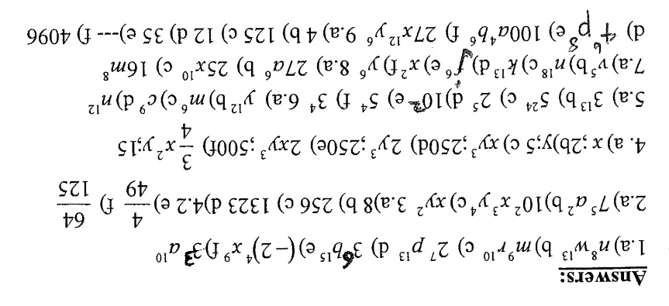
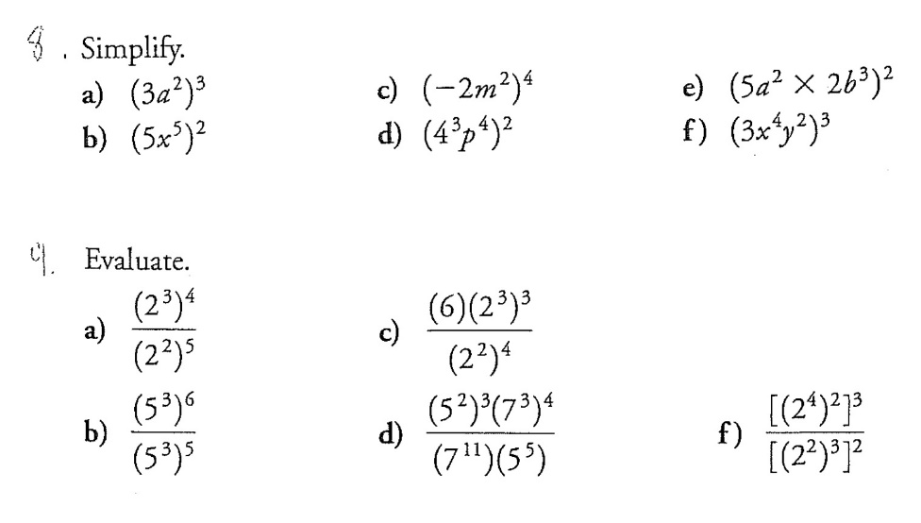

Negative and Zero Exponents – Homework Handout #2

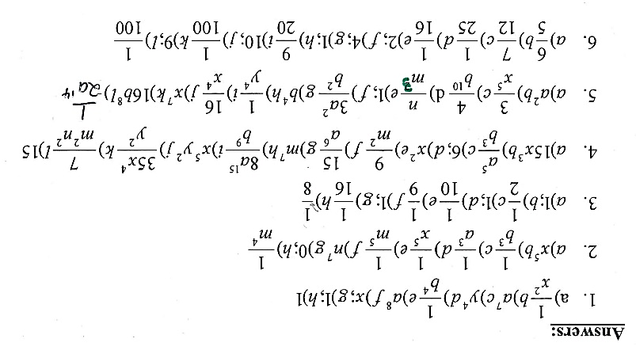
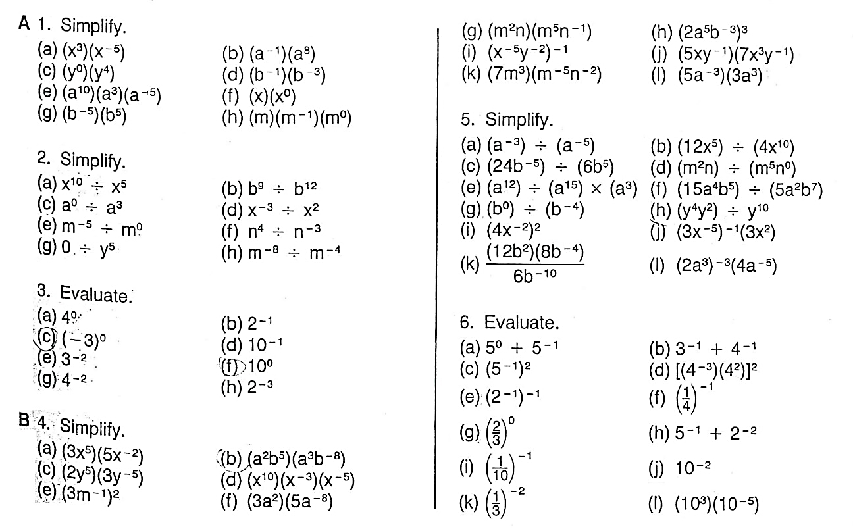
Section 3.1: Polynomials
MathPower 10, Ontario Ed., McGraw-Hill Ryerson p. 128-133

By the end of this lesson, you should be able to:
- Define what a monomial, polynomial, numerical coefficient and a term means
- Determine the degree of a polynomial
- Simplify polynomials by adding, subtracting or dividing
- Multiply polynomials, expand and simplify polynomials

A monomial is a number, a product of one or more variables or the product of a number and one or more variables. A numerical coefficient is the number multiplying the variables. Examples of monomials include:

32 | 7x  This is a numerical coefficient. | -3ab⁴
The circled portion is called a TERM.

A binomial is an algebraic expression with TWO terms. Examples of binomials are as follows below:

x + 17 | a² – b²
Each TERM is separated by addition or subtraction.

A trinomial is an algebraic expression with THREE terms. Examples of trinomials are as follows below:

a + b - 18 | x² + 2xy + y²

A polynomial is simply the term used for an expression with more than one terms. Use monomial, binomial and trinomial specifically when classifying them; otherwise, any expression with more than three terms is just classified as a polynomial.

The DEGREE OF A TERM is obtained by adding up the exponents of the variables the term. Determine the degrees of the terms below:
35 | 2x² | -3a²b | m²n⁵p

The DEGREE OF A POLYNOMIAL is simply the highest degree of any of its terms.

Polynomial | Number of terms | Classification by terms | Degree | Classification by Degree
3

2b

4m + 3

2n² + 2n + 1

3x³ - 4x² + 2x - 5

Typically, when writing a polynomial, you write the expression in terms of descending order of degree (i.e., highest exponent to lowest exponent.)
When simplifying polynomials, the key to preventing mistakes is to collect like terms.

Simplify $\left({2x}^{2}+3x+2\right)+(x^{2}+2x-5)$ | Simplify $\left(5x^{2}+4x-7\right)-(6x^{2}-3x+3)$

Expand and simplify $2x\left(x-3\right)-4(x^{2}+x)$

When dividing monomials, collect the like terms so that they line up on top of each other. This allows you to easily use the exponent rules. Typically, it is assumed that the denominator is not equal to zero.

Simplify $\frac{-15x^{3}y^{2}}{3x^{2}y}$ | Simplify $\frac{-36xy^{2}}{4y^{2}}$

When multiplying monomials, it is also advisable to put the like terms beside each other. Again, this makes it easier to perform the exponent rules.

Multiply the following expression: (4xy³)(-2x²y)

Section 3.2: Multiplying Binomials
MathPower 10, Ontario Ed., McGraw-Hill Ryerson p. 134 - 139

By the end of this lesson, you should be able to:
- Multiply two binomials using the FOIL method
- Simplify the resulting polynomial

Recall the distributive property:

$$x \left(x+3\right)$$

The same property applies for multiplying binomials. Apply the FOIL method.

$$\left(x+1\right) (x+2)$$

Expand and simplify the following binomials.

$$3(2x-1)(x+4)$$ | $$2\left(m+3\right)\left(m+5\right)+4(2m+3)$$

Section 3.3: Special Products
MathPower 10, Ontario Ed., McGraw-Hill Ryerson p. 140 - 145

By the end of this lesson, you should be able to:
- Identify patterns for squaring binomials (a + b)² and (a – b)²
- Know the product of the sum and difference of two terms (i.e., (a + b)(a – b) = a² - b²)

Expand and simplify the following expression ${(a+b)}^{2}$

CONCLUSION:

Use your conclusion above to quickly expand the expressions ${(x+3)}^{2}$ and ${(2x+3)}^{2}$

Expand and simplify ${(a-b)}^{2}$

CONCLUSION:

Use your conclusion above to quickly expand the expressions ${(b-2)}^{2}$ and ${(3m-2)}^{2}$

Expand and simplify the expression $(a+b)(a-b)$

CONCLUSION:

Expand $(2x+3)(2x-3)$ | Expand $(5m-4n)(5m+4n)$

Expand and simplify the following expressions:

$${(2x-4)}^{2}-(3x-1)(4x+5)$$ | $${2(1-t)}^{2}-4(1-3t)(1+3t)$$

